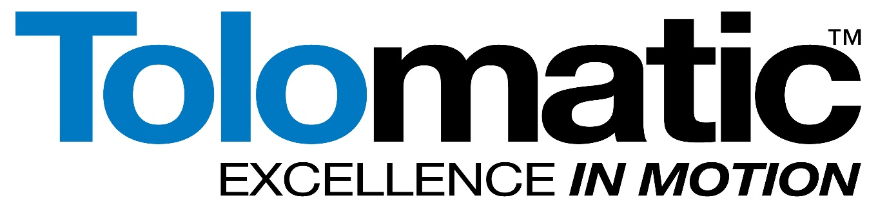

Supplier Handbook
PUR-REF-001 | Rev. 4

Tolomatic
3800 County Road 116
Hamel, MN 55340

Main Phone: 763-478-8000
Main Fax: 763-478-8707
Website: https://www.tolomatic.com/

Contents
1. Supplier Handbook Objective 3
2. Company Profile 3
3. Quality Policy 4
4. Supplier Expectations 4
5. Supplier Evaluation Survey 5
6. Purchase Order Issuance 5
7. Order Acknowledgment 6
8. Over/Under Shipments 7
9. Safety Data Sheets (SDS) 7
10. Material Certifications 7
11. Product Labeling / Shipping Documentation Specifications 7
12. Packaging Requirements 9
13. Delivery Requirements 10
14. On Time Shipping Expectations 10
15. International Shipping Requirements 10
16. Quality Assurance Requirements 12
17. Quality System Management 13
18. Change Management 14
19. Advance Deviation Request 14
20. Nonconforming Products 15
21. Counterfeit Parts 15
22. Supplier Corrective Action Requests (SCAR) 16
23. Compliance 16
24. Discounts for Non-Compliance 17
25. Supplier Performance Metrics 17
26. Tolomatic Tooling 18
27. Confidential Information Policy 18
28. Acceptance of Gifts and Gratuities 18
29. Supplier Anti-Trafficking and Forced Labor Policy 18
30. Packaging Examples 20
SUPPLIER HANDBOOK ACKNOWLEDGEMENT FORM 21
Revision History 22

Supplier Handbook Objective
Our Suppliers are central to our long-term success and to the support of Tolomatic’s customers. This Supplier Handbook has been designed to communicate Tolomatic’s expectations in doing business with our current Suppliers and Suppliers interested in doing business with Tolomatic. Throughout, you will be introduced to Tolomatic business practices and general expectations of our Suppliers. We realize providing better products and services through a more efficient distribution process translates into total supply chain customer satisfaction.

Company Profile
Since 1954, Tolomatic has been manufacturing innovative automation components. From gearboxes and brakes to pneumatic actuators and complete electrical linear motion systems, our motion solutions are moving businesses forward. Tolomatic designs, manufactures, and markets automation components in three different technologies: Electrical linear motion, Pneumatic motion and Power Transmissions. Tolomatic is committed to being the premier supplier of world class motion control products. We are focused on meeting customer requirements and supplying them with exceptional support.

Quality Policy
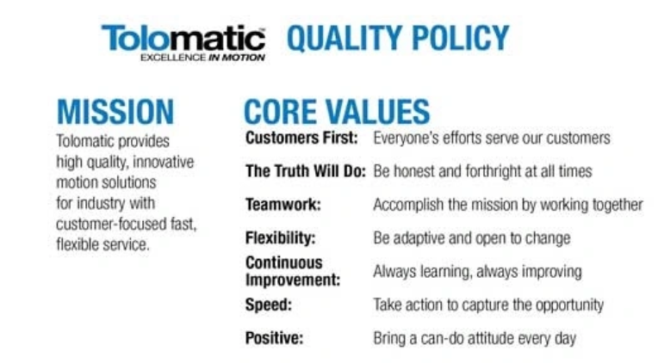

Supplier Expectations
Tolomatic has the following expectations from our Suppliers:
- Be Complete: Communicate with complete and detailed messages.
- No Surprises: We can handle the truth.
  - Open communication and information regarding shipment delays. o Complete disclosure of any quality variations or process capability concerns.
  - Be proactive, anticipate and communicate with Tolomatic team members if something feels wrong or out of character.
  - Be forthcoming about your production/manufacturing capabilities.
  - Ensure the appropriate quality assurance checks are in place to prevent potential problems.
- Innovative Growth Opportunities: Look for opportunities to improve your Supplier performance and grow your business with Tolomatic through engineering and process improvement innovations.
- Competitive Landscape: Provide Tolomatic with competitive products and services to help us remain a leader in our industry.
- Risk to Supply: Tolomatic expects our Suppliers to provide notice to Tolomatic purchasing of any risk to supply. Supply risk can be the result of production issues, material shortages, labor, national holidays or transportation issues.
- Supply Chain Efficiency: Work with your Suppliers and internal personnel to reduce the costs of producing and distributing products and minimize leadtimes.

Supplier Evaluation Survey
All Suppliers wishing to conduct business with Tolomatic are required to fill out a Supplier Evaluation Survey to be evaluated by Tolomatic before a Supplier relationship will be undertaken. Execution of the Supplier Evaluation Survey does not create an obligation on the part of Tolomatic to purchase products from a particular Supplier.
Additional evaluations may be required to become an approved Supplier to Tolomatic which may include Supplier audits, verification of financial stability, evaluation of product samples and/or process capabilities. These items will be at the discretion of the buyer and will be dependent upon the critical nature of the products being supplied to Tolomatic.
Tolomatic encourages the adaptation of ISO Management principles, but is currently not a requirement of doing business. Preferential treatment may be given to those organizations who are certified or fully comply with the ISO systems. If your organization is ISO certified, please forward a copy of your certificate to Tolomatic purchasing.

Purchase Order Issuance
Tolomatic purchase orders are processed for identified materials with specific quantity and delivery requirements. Purchase orders can be set up as blanket agreements, releases, or spot buy orders. All purchase orders will be sent via email to Supplier contacts identified. Any personnel changes or contact updates should be communicated to the appropriate Tolomatic buyer to assure continuity in communication.
Tolomatic purchase orders identify the costs based on pricing agreements, quotations or historical trends. Any deviations from the purchase order costs must be communicated to the appropriate buyer for approval prior to shipment of the purchase order.
Purchase orders that are communicated as Hot should be expedited to the best of the Suppliers abilities and shipment notification information, including tracking numbers should be communicated to the Tolomatic buyer.
Tolomatic will work with Suppliers on minimum order quantity requirements (MOQ), but we will give preference to Suppliers who consistently work to reduce the MOQ of their products.
Any changes to MOQ’s need to be approved by Tolomatic purchasing prior to implementation.
Tolomatic reserves the right to change, reduce or cancel purchase orders for product not produced or shipped against any purchase order. Tolomatic Purchase Order Terms and
Conditions govern all purchase order agreements, along with the contents of this Supplier Handbook. Tolomatic Purchase Order Terms and Conditions are included as Addendum A in this manual and can be found on the Tolomatic website www.Tolomatic.com.

Order Acknowledgment
All Purchase Orders should be acknowledged upon receipt and approval. Acknowledgments should include but are not limited to: complete description of what is being ordered, quantity, due date (Tolomatic dock date), price, part revision, terms and shipment details.
Acknowledgments should be communicated to the appropriate buyer via email.
Any exceptions that are being taken to the PO requirements should be clearly stated and obvious on the Order Acknowledgment. See Section 13 for more information on expectations meeting purchase order quality requirements. Suppliers are responsible for making sure they have the most current revision print documents on file and should contact Tolomatic purchasing if there is a discrepancy. Product produced must match the revision level identified on the purchase order.

Over/Under Shipments
Tolomatic requires its Supplier to produce and deliver product at the quantities reflected on its purchase orders. Given manufacturing constraints, Tolomatic recognizes that this may not always be possible and manufacturing overruns/underruns may occur. Underruns will not be accepted unless approved by your Tolomatic buyer. The following standards have been established to account for acceptable overages allowable based on the PO order quantity:
1 to 100 units | +10% overage
101 to 500 units | +5% overage
501 to 2,500 units | +2% overage
2,501 to 20,000 units | +1% overage
20,001 to 100,000 units | +0.5% overage
If over shipments beyond the stated percentages are received without prior Tolomatic approval, we reserve the right to pay only for the order quantity and the acceptable overage percentage when the invoice is processed.

Safety Data Sheets (SDS)
Tolomatic requires SDS be supplied for any hazardous materials. Appropriate SDS sheets should be submitted with packing slip when product is shipped into Tolomatic.

Material Certifications
When material certs are requested on the purchase order, they should be submitted with the packing slip when product is shipped to Tolomatic. All special processes require material certifications – this is indicated on the Tolomatic purchase order.

Special Processes
Per ISO 9000 3.4.1 Note 5, a special process is defined as, “A process where the conformity of the resulting output cannot be readily or economically validated”. Common examples of special processes include: Heat Treating, Welding/Joining, and Surface Treatments (such as anodizing, painting, coating, and plating).

Product Labeling / Shipping Documentation Specifications
Proper labeling is critical to efficient receiving operations at Tolomatic. Each Supplier must follow these instructions and provide the necessary paperwork for proper receiving and payment. Product identification on the outside of cartons is required for all shipments into
Tolomatic, including miscellaneous requests without a PO and items paid with a credit card.
If items are being drop shipped by your vendor, it is still a requirement to reference Tolomatic part numbers and purchase orders on all shipping paperwork and packaging.
Carton Markings should include the following information:
- Tolomatic part number – Barcode required (8 digit PN including leading 0’s)
- Purchase order number – Barcode required (Numerical PO# only)
- Tolomatic part description
- Quantity per carton - (optional barcode)
- Carton Count (1 of xx, 2 of xx) - (optional barcode)
- Packing Slip number – (optional barcode)
- Attention To – only required for miscellaneous items without a PO or credit card orders
- Mixed Carton Identification – when multiple products are included in one carton
Bar Coded Label examples: (Bar Code should be in Code 128)
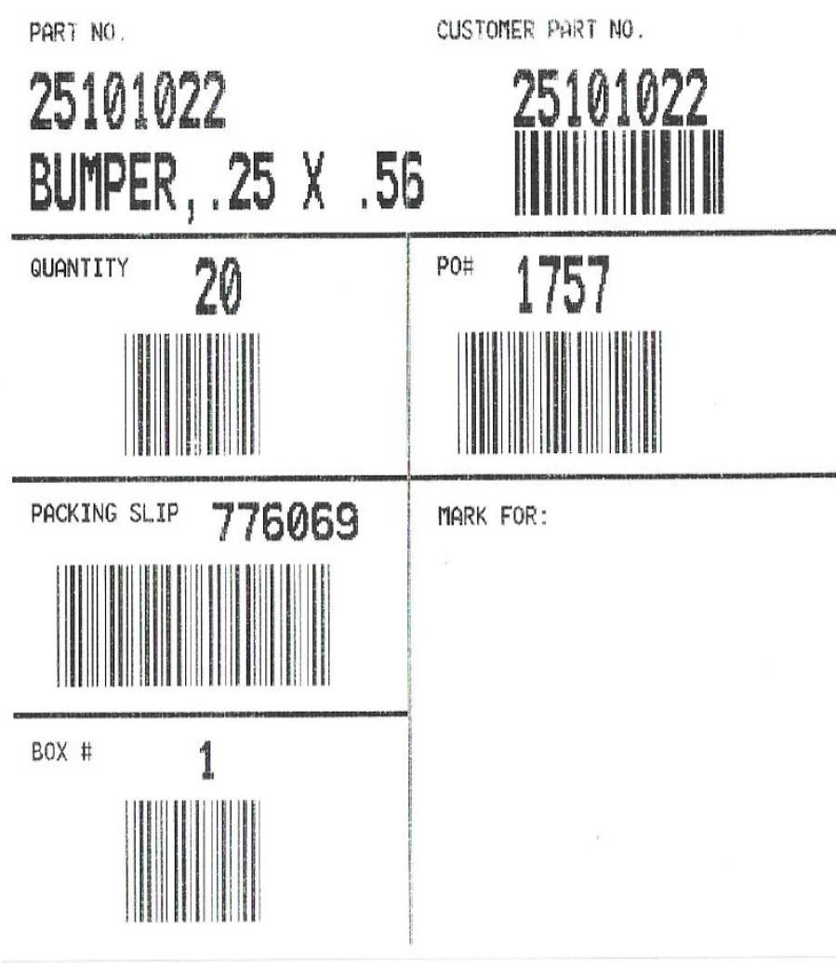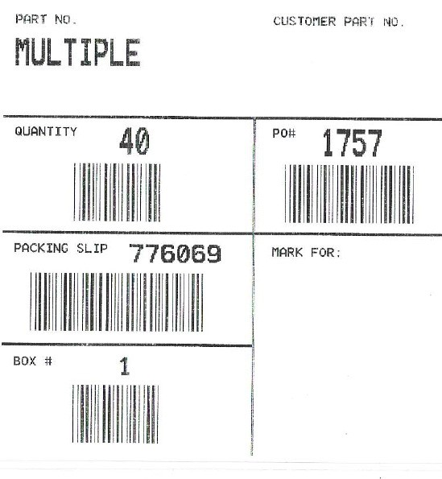

Packing Slip Documentation should be included with the shipment contained in a packing slip envelope on the outside of the FIRST carton.
The packing slip should include the following minimum information:
- Purchase order number and corresponding Line #, if appropriate
- Tolomatic part number
- Tolomatic part description
- Quantity shipped, including unit of measure
- Incomplete shipments should be identified with a Backordered status
- Carton Count w/standard case quantities (number of pallets is not sufficient)

Packaging Requirements
All Suppliers are required to comply with basic packaging standards when supplying product to Tolomatic. Suppliers are responsible for ensuring the integrity of the shipments to Tolomatic and it is the expectation that all product receipts are received without damage. These requirements are also in place to ensure safe material handling practices for all involved.
- All product should be packaged to withstand normal handling practices of small parcel package handlers. This may require additional padding, heavier cartons or internal protectant materials. It is the expectation that product is received without damage.
- Max Carton Weight: 50 lbs per carton for items shipped in unpalletized.
- Mixed cartons are acceptable as long as there is special identification on the outside of the carton stating “Mixed.” When product is mixed within a carton, individual product identification is required on each product contained within the same carton.
- Max Skid Weight: 2,500 lbs. unless prior approval is obtained in writing from Tolomatic.
- Product shipped in on pallets, whether boxes or raw parts, should be properly secured to pallet using either clear shrink wrap of sufficient gauge and poly banding.
- Bundles of tubing and bar stock will be limited to a max lift of 2,500 lbs. and be properly banded. Bundles should be packed to protect cosmetic surfaces where necessary.
- Wood packaging, crates, or returnable containers may be requested by Tolomatic on a case by case basis and will be communicated to the Supplier separately.
- Please see Packaging Examples for examples of packaging pictures that are deemed acceptable.

Delivery Requirements
Tolomatic does not require delivery appointments, however if delivery is attempted outside of normal receiving hours without prior approval, shipments may be turned away. Tolomatic standard receiving hours are 7 am to 5 pm (freight unloaded by 5 pm), Monday through Friday. In the event of any nonstandard delivery attempt, prior authorization must be obtained from either Tolomatic Shipping or Purchasing departments.
Ship Via’s and FOB Points will be identified on the Purchase Order. If there is an opportunity to save freight costs through other shipment methods, please contact the appropriate buyer to discuss.

On Time Shipping Expectations
While Tolomatic recognizes our aggressive delivery expectations, we carefully analyze a Supplier’s ability to ship and deliver products in a reasonable amount of time and deliver on time, in order for Tolomatic to support our customer’s needs and expectations. All shipments should be received on or before the Tolomatic Dock Date stated on the PO unless other arrangements have been made in writing with Tolomatic. On Time delivery performance is monitored and reviewed. Any late deliveries should be communicated to your Tolomatic buyer.

International Shipping Requirements
Tolomatic expects all of its Suppliers to comply with all import requirements of US Custom and Border Protection and US Government agencies. US Customs has extremely specific requirements for the information, documentation and markings required for the entry of product into the United States. Failure to adhere to these requirements may result in delayed delivery and additional expenses.
Country of Origin Marking: All products must be accurately marked with its country of origin in compliance with the import laws and regulations. Product and cartons must be clearly and legibly marked with the complete name of the country of origin in English. Where physical marking of the product is prohibitive, then country of origin needs to be clearly identified on its shipping container and all Shipping documentation paperwork.
Shipping Documentation: All shipments must be accompanied with the required shipping and entry documentation as required by US Customs. Accurate and correct documentation is important to prevent any unnecessary delays with US Customs, including correct part numbers, country of origin markings, manufacturer / shipper names and addresses, correct pricing, part counts, weights and measurements, etc.
Commercial Invoice must contain the following information at a minimum:
- Sold to name and address
- Ship to name and address
- Invoice Date
- Purchase order number, line number if appropriate
- Part number and description
- HTS Code
- Quantity and unit of measure
- Unit cost in currency of purchase and Total cost in currency of purchase
- Country of Origin
- Shipping terms and Payment terms
Packing List must contain the following information at a minimum:
- Sold to name and address
- Purchase order number, line number if appropriate
- Part number and description
- Carton quantity, weight and carton dimensions
- Total quantity, gross and net weights, and total dimensions
- Total cartons in shipment
Certificate of Origin: Certificate of Origin is required with each shipment certifying the country of origin for each part number within the shipment.
Shipping Instructions: Shipments originating outside of the United States will have specific routing instructions and should be processed through our International Freight Forwarder, Landstar Global Logistics Agency.
Landstar Global Logistics Agency (CSW)
℅ Innovative Transport Solutions
Suite B., 325 West Lake Street
Elmhurst IL 60126
Sherwood Edwards
Sherwood.edwards@landstarmail.com
Office:-+1 630 350 2402 Ext. 104

Quality Assurance Requirements
Tolomatic Engineering, Quality, Purchasing and Operations departments are committed to working with our Suppliers to deliver quality products. All products purchased by Tolomatic must meet or exceed the print specifications and quality requirements of any final first article samples approved by Tolomatic.
All orders referencing a Tolomatic part number revision should be produced to the current revision level stated on the Purchase Order. It is the responsibility of all Tolomatic Suppliers to verify the drawing they have on file matches the stated current revision level at the time of order acknowledgment. Acceptance of a Purchase Order is acceptance of all specifications identified on the drawing including print tolerances, finish requirements and special notations. Where the drawing identifies “or equivalent”, any substitutions must meet the original intent of the drawing specifications in its entirety and be pre-approved with the Tolomatic Advance Deviation Request (ADR) process noted in Section 16. The Tolomatic drawing is the primary document of which Supplier’s parts will be inspected during incoming inspection, and to which the Supplier will be held accountable. Any variations will result in rejection and a Rejected Material Record (RMR) will be generated.
Tolomatic also maintains Quality Document QA-WI-003 identifying the Standard Manufacturing Practices which is to be utilized as a supplement to the Tolomatic drawings to define additional drawing interpretations and standard acceptable manufacturing practices. It is the Suppliers responsibility to be familiar with these requirements and adhere to them as part of the overall quality requirements. This document will be accessible on the Tolomatic website.
Any exceptions to drawing requirements must be approved by Tolomatic prior to shipment and will be documented with an Advanced Deviation Request (see Section 16). Sending nonconforming material ahead of an approved ADR will result in a RMR. Tolomatic encourages all Supplier’s to maintain open communication in the event of questions or concerns.

Quality System Management
Tolomatic tolerance expectations are identified on our drawings and because of the critical nature of our product assemblies and stack up tolerances, many of these tolerances are very tight and critical that they be held within your Supplier processes. Tolomatic expects Suppliers to have a comprehensive understanding of quality management systems and process validation and verification principles. This knowledge extends to the following methodologies:
- Statistical Process Controls
- Measurement Systems Analysis (MSA)
- Production Part Approval Process (PPAP)
- Process Potential Failure Modes and Effects Analysis (PFMEA)
- Cpk and Ppk Measurements
- Continuous Improvement
At a minimum, Suppliers should implement process controls for critical characteristics on Tolomatic drawings. Additional characteristics deemed important to the overall use of the product in Tolomatic’s assembly should also be considered for statistical process control. Tolomatic may require data from our Suppliers on critical parts so that process capabilities can be verified and validated.
Note - The body responsible for the verification of the Ex quality management system (Intertek) may verify aspects of the supplier's operation that may affect ATEX requirements.

Change Management
If any standard product specifications change on catalog or standard products that may affect form, fit or function of intended uses at Tolomatic, please notify your Tolomatic Engineering and Purchasing contacts with the new specifications.
Once custom products are approved for production by Tolomatic and Supplier starts providing parts, any changes to the process requires notification to Tolomatic through the Advanced Deviation Request (ADR) of those changes and re-approvals may be required. This change notification includes the following:
- Outsourcing to secondary Suppliers
- Change in production equipment, tooling or measurement gages
- Change in process steps or procedures

Advance Deviation Request
Any exceptions to drawing requirements must be approved by Tolomatic prior to shipment and should be documented on the Advance Deviation Request (ADR) form and submit to your Tolomatic buyer contact and/or Tolomatic supplier quality. Once this request is received, it will be reviewed for acceptability and formal disposition. If the deviation request is approved, the Supplier (or Originator) will receive a copy of the completed ADR from Tolomatic purchasing to submit with the product shipment. Any deviations granted are limited to only the purchase order indicated on the ADR form. ADR’s are not intended to be blanket documents covering multiple purchase orders.

Nonconforming Products
In the event Tolomatic identifies product that does not conform to the drawing requirements, the Tolomatic buyer will send notification of the rejected material detailing the
Non-conformities and collaborate to determine the best recovery process and the products final disposition based on one of the following:
- The Supplier provides authorization to Tolomatic to sort and apply modifications to defective product as needed, at the Supplier’s expense. Tolomatic will provide the vendor with estimated costs either through email communication or the Tolomatic Rework Cost Recovery Form detailing the cost estimates of the rework. Associated debit memos will be processed to the Supplier for these rework expenses once completed and processed through Tolomatic Accounting.
- Product will be returned to the Supplier at the Supplier’s expense for rework or replacement. When materials will be replaced, the Supplier may authorize Tolomatic to scrap out material at our facility to avoid the shipping expense of returning the material.
- The Supplier sends a representative to Tolomatic to rework material on site.
When Nonconforming materials are identified at Tolomatic, the Supplier is notified and it is our expectation that immediate containment actions are put into place to identify any additional material within the supply chain either in transit or at the Supplier’s facility and this suspect material evaluated for the nonconforming condition.

Counterfeit Parts
Tolomatic has zero-tolerance for counterfeit parts. Counterfeit parts will not be accepted in the manufacturing or repair processes and will be removed from all stages of production and service. This includes parts or components that are fraudulently misrepresented as having been produced by an authorized manufacturer, including those that do not meet safety, performance, or regulatory standards.

Supplier Corrective Action Requests (SCAR)
If a Supplier is notified of Nonconforming material a Supplier Corrective Action may also be requested. Tolomatic is questioning why this product was made and why this product was shipped. The corrective action evaluation should include identifying the root cause and any short term and long term permanent corrective action implementations. It is imperative that the true root cause is identified in this evaluation to ensure corrective actions are not just addressing a symptom of the underlying problem.
Corrective action requests should be acknowledged within 48 hours and it is imperative that all product nonconformities be handled as expeditiously as possible to avoid delays in manufacturing and meeting our customer shipping expectations.
Completed corrective action responses should be submitted to Tolomatic supplier quality for review and acceptance. This response is expected in a matter of days, not weeks.

Compliance
Tolomatic Suppliers must comply with the Purchase Order Terms and Conditions, this handbook and all laws, rules and regulations of the United States, individual states and localities applicable to the Suppliers business and its products and or services being offered to Tolomatic. This includes, when applicable, registration, notification, and payment of fees as required by any governmental agency for particular product or service categories.
Tolomatic reserves the right to refuse products from a Supplier that does not meet our requirements or fails to comply with applicable federal or state laws and regulations. The Purchase Order Terms and Conditions provide remedies to Tolomatic for a Supplier’s failure to comply with these requirements including any penalties or other charges assessed against Tolomatic as a result of the Supplier’s acts or omissions. The location of Tolomatic Purchase Order Terms and Conditions can be found referenced on all Purchase Orders.

Discounts for Non-Compliance
Tolomatic’s objective is to foster productive Supplier partnerships, while at the same time, creating an environment whereby we can rapidly and efficiently bring your products into our facility. By communicating our expectations ahead of time, we hope to avoid confusion, misunderstandings and subsequent non-compliance chargebacks.
Tolomatic may take additional discounts for non-compliance with the performance expectations set forth in the individual Purchase Order, Purchase Order Terms and Conditions, or this Supplier Handbook. Discounts may be taken for failure to comply with applicable performance metrics including, but not limited to, the following:
- Shipping requirements
- Product quality
- Regulatory requirements
- On-time Delivery
- In-full delivery
- Packaging requirements
- Any other requirements specified in an individual purchase order.
Discounts taken may be deducted from Supplier invoices at the time of payment.

Supplier Performance Metrics
Tolomatic measures Supplier Performance on a quarterly basis for both Quality and Delivery performances. Quality is measured by part number shipment lots accepted versus shipment lots rejected. Delivery is measured based on shipment lots received within the delivery window identified above. Performance Metrics are sent to Suppliers for their review and it is the expectation of Tolomatic that all Suppliers maintain the following performance levels:
- Quality – 90%
- Delivery – 80%
In the event a corrective action is initiated to a Supplier for performance deficiencies, it is the expectation that 8D Problem solving methodologies will be utilized in root cause identifications and corrective action implementations.

Tolomatic Tooling
Any tooling purchased by Tolomatic to support production of a part number will remain the property of Tolomatic while at the Supplier’s premises. It is the Supplier’s responsibility to maintain the tooling to withstand normal wear and tear and track and report life of tooling to Tolomatic so proper replacement can be planned appropriately. In the event tooling is damaged as a result of negligence at the Supplier, it is the expectation that the Supplier will repair and incur any expenses to bring the tool back to a useable state.

Confidential Information Policy
All Suppliers will be required to comply with the Tolomatic Non-Disclosure policies and signed documents will be required when concerning confidential information of Tolomatic. It is
Tolomatic Policy to ensure its operations, marketing plans, designs, supply chain activities, and other business affairs, as well as confidential information entrusted to us by our customer, strategic partners, and Suppliers are kept confidential. If a Supplier acquires confidential or proprietary information about Tolomatic, this information is to be kept in strict confidence and is not to be discussed with anyone outside of the Tolomatic/Supplier relationship.

Acceptance of Gifts and Gratuities
Tolomatic’s policy states that employees may not give or accept any excessive gifts or invitations that might indicate intent to influence improperly the normal objective business relationship between Tolomatic and any Supplier, customer, or competitor.

Supplier Anti-Trafficking and Forced Labor Policy
Tolomatic maintains a zero-tolerance policy toward human trafficking, slavery, forced labor, and child labor in all operations and supply chains. We expect our suppliers to share this commitment and to operate in full compliance with all applicable laws and international standards.

Suppliers shall not engage in or support any form of human trafficking, slavery, or forced, bonded, or indentured labor. This includes, but is not limited to:
- Withholding or destroying employees’ identity or immigration documents;
- Charging recruitment or placement fees;
- Restricting freedom of movement, communication, or the ability to terminate employment;
- Using coercion, deception, threats, or any other form of exploitation to obtain or retain labor.

Suppliers must ensure that:
- Recruitment is conducted in compliance with all local and international labor laws;
- Workers are informed of their employment terms in a language they understand; and
- Employment is voluntary and free from coercion.

Tolomatic reserves the right to audit or inspect supplier operations to verify compliance with this policy. Non-compliance may result in corrective action, suspension, or termination of the business relationship.

Suppliers are required to promptly report any suspected or confirmed violations of this policy to the Global Human Trafficking Hotline at 1-844-888-FREE and its email address at help@befree.org. Reports may be made confidentially and without fear of retaliation.

Packaging Examples
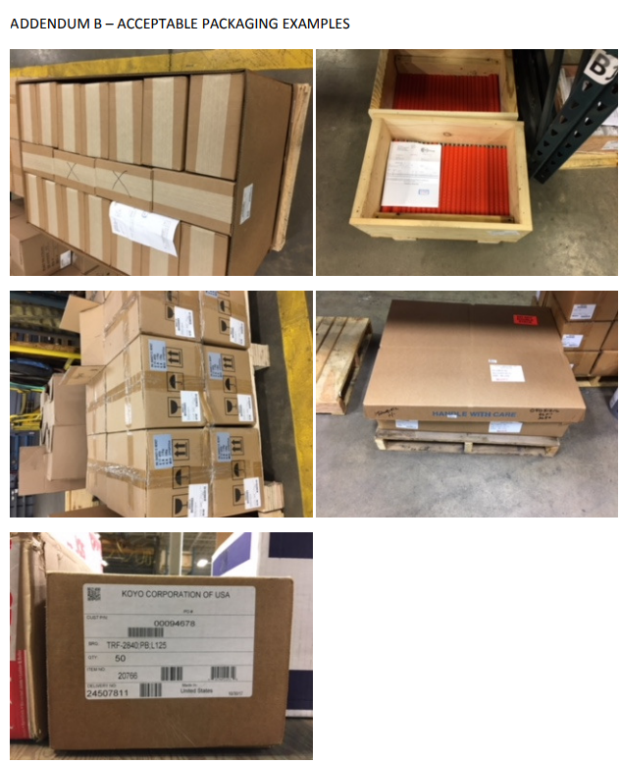



SUPPLIER HANDBOOK ACKNOWLEDGEMENT FORM

Supplier Name: _______________________________________
Supplier Signature: ____________________________________
Print Name: ___________________________________________
Date: ______________________

We acknowledge that we have read and understand the contents of the Tolomatic Supplier
Handbook and understand the requirements and my responsibilities as a Supplier to Tolomatic. We have distributed copies of and reviewed the contents of this handbook with appropriate associates within my company for adherence to these requirements.

Please email this signed acknowledgement to Tolomatic.
Email to: Purchasing@tolomatic.com

Revision History
Date | Rev | Reason for Change | Author
3/31/25 | 1 | Updates per CAPA 1741 – including :  - Added Quality Policy into our Company Profile in Section 1  - Added a Rev table to this reference doc  - Added Addendum B | Jay Hoffman
4/15/25 | 2 | Updated to add a counterfeit parts section into the Non-conforming parts section, (section 17) | Jay Hoffman
11/4/25 | 3 | Added ‘Supplier Anti-Trafficking and Forced Labor Policy’. Updated layout for clarity and improved navigation. Normalized formatting throughout the document. Changed revision control from alphabetical to numerical to match Tolomatic documentation standards. Renamed doc PUR-REF-001 and moved into the DIL, per TOL-WI-001. | David Markman
4/29/26 | 4 | Updated Section 10 to reference special processes, added Section 11 defining special processes. These updates are part of CAPA 1780. | David Markman

Note - If you made a revision change to this document, you must update the copy of the document published on the following customer-accessible site:
https://mail.tolomatic.com/purchasing/
To accomplish this, you must contact IT.

